Preheating Draft
September 1,2021
smart celebrates world premiere of the Concept #1 at IAA MOBILITY 2021
（September 1, 2021，HangZhou）The starting signal of a new era for the pioneer of electric urban mobility: with the smart Concept #1, the forerunner of the next smart generation celebrates its world premiere at the IAA MOBILITY 2021 in Munich. The fully electric SUV concept provides a preview of the first production model from the newly established smart Automobile Co., Ltd. which is a global joint venture of Mercedes-Benz AG and Geely Automobile Group Co., Ltd. At the same time, the smart Concept #1 shows how smart as a brand is developing into a global provider of connected, battery-electric premium compact vehicles for different customer groups. Starting with the SUV, smart will expand its portfolio to the promising small- and compact-car segment.
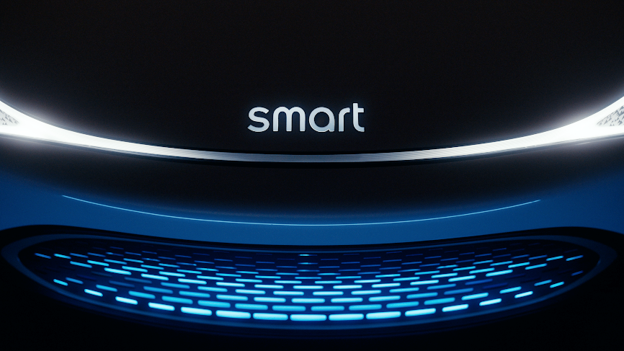
2021 IAA Munich Auto Show All-new smart Concept #1 World Premiere
As previously announced, the smart Concept #1 combines the iconic design typical of smart with compact exterior dimensions in a new vehicle concept that represents the brand's growing premium and high-tech aspirations. With a generously dimensioned interior, the future SUV addresses target groups such as young families who seek sustainable electric mobility as well as trendsetters of the urban avant-garde. Apart from the new design – including exceptional lighting features -the highlights of the concept are its spacious and comfortable interior as well as a high level of connectivity and vast array of advanced driver assistance features.

All-new smart Concept #1
World premiere will be streamed live on September 5th
The world premiere of the smart Concept #1 will take place on September 5th as part of the Mercedes-Benz Pre-Night and will be broadcast as a livestream on media.mercedes-benz.com starting at 7:15 pm CET.
At the IAA MOBILITY, the smart Concept #1 will be on display as of the first press day, September 6th, at the Mercedes-Benz stand in Hall B3, and from September 7th onwards at the Mercedes-Benz Open Space Experience Landscape in a prominent location on Odeonsplatz.
- End–

For further information about smart, please visit https://media.smart.com/zh-chs/

The media inquiries:
smart Automobile Co., Ltd.
Sebastian Liu: sebastian.liu@smart.com
Ella Wang: ella.wang@smart.com

