Press Release
March 23, 2023

smart Teams with NVIDIA to Develop Intelligent Mobility Solutions and New Data Centre
- Future all-electric smart vehicles will be built on the NVIDIA DRIVE Orin system-on-a-chip (SoC) starting in 2024.
- smart and NVIDIA will together build a new data centre for ongoing research and development of advanced intelligent assisted driving and AI systems.

(March 23, 2023, Hangzhou) — smart, the new-premium intelligent all-electric auto brand, announced today it will develop intelligent mobility solutions with NVIDIA. Through this collaboration, the companies will work together to develop a new data centre for advanced intelligent assisted driving and AI systems. smart will build its future all-electric products on the NVIDIA DRIVE Orin system-on-a-chip (SoC) to provide a “smarter” future urban mobility experience for its global customers, with start of production expected by the end of 2024.
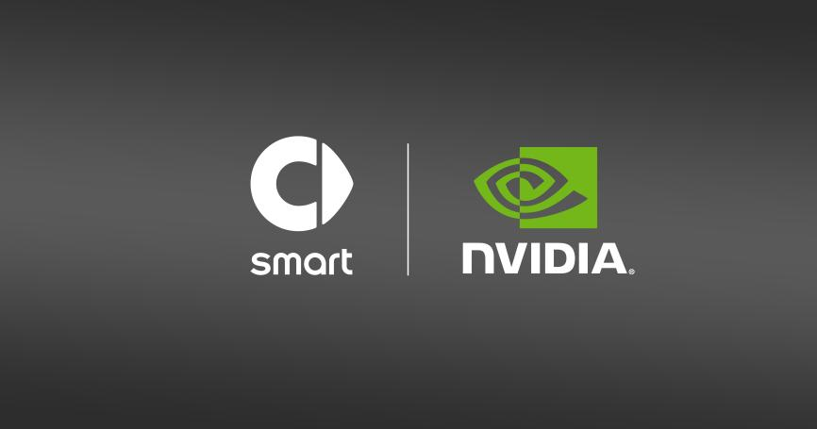
smart is joining hands with NVIDIA to develop a smarter mobility solutions
Mr. Yang Jun, Vice President of Research and Development of smart Automobile said, “smart is delighted to begin this long-term collaboration with NVIDIA in the field of intelligent driving, accelerated computing and software research and development. smart will continue to develop a safer and more reliable intelligent travel experience, co-creating with industry partners and applying the advanced technology to become our customers’ best companion for the cities of tomorrow.”
Mr. Yang Jun, Vice President of Research and Development of smart Automobile
A Strong Partner for Tomorrow’s Urban Mobility
Starting in 2024, smart will use the NVIDIA DRIVE Orin SoC as the computing platform for its all-electric products. The high-performance SoC will enable smart’s proprietary Pilot Assist intelligent driving system to deliver an even “smarter” mobility experience. In addition, smart will work with NVIDIA to build a dedicated data centre for the development of highly advanced assisted driving and AI systems to explore cutting-edge mobility applications.
“NVIDIA and smart are working together to create highly programmable, software-defined vehicles that get better and safer over time,” said Mr. Tong Liu, NVIDIA’s general manager for automotive in China. “We believe that with the help of NVIDIA's data centre solutions for autonomous driving development, smart can provide customers with a safe, efficient and continuously updated mobility experience.”
Mr. Liu Tong, NVIDIA General Manager for Automotive in China
NVIDIA DRIVE Orin is built for software-defined vehicles, allowing for continuously upgradable driving capabilities and features throughout the entire vehicle lifecycle via over-the-air software updates. As the world's leading automotive-grade SoC, NVIDIA DRIVE Orin, delivering up to 254 trillion operations per second, provides the ample computing headroom necessary for the large number of applications and deep neural networks that run in autonomous vehicles, while achieving system safety standards such as ISO 26262 ASIL-D.
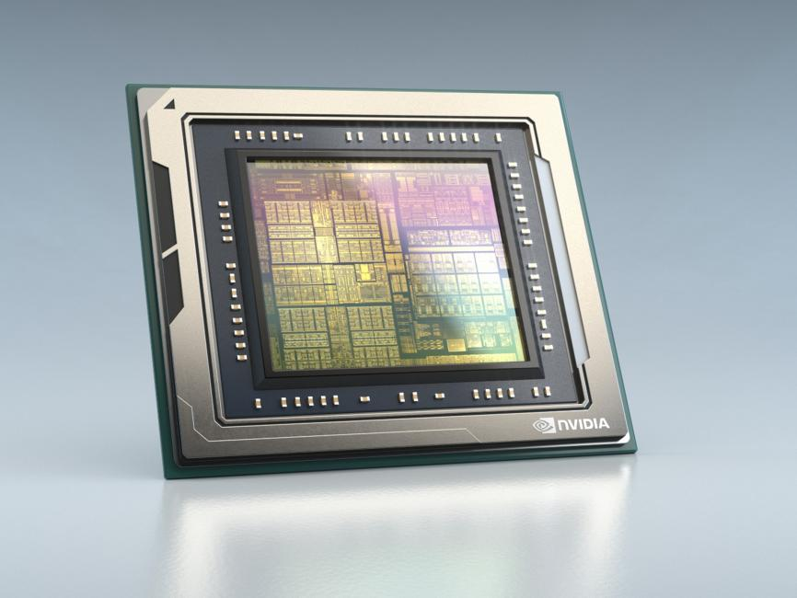
NVIDIA DRIVE Orin Soc
Enhancing Technology the smart Way
With a mission to enhance the smart brand through the development of full-stack, intelligent driving software, smart officially established smart Robotics Technology company in Shanghai in 2022 as a wholly owned subsidiary. Committed to building an industry-leading intelligent assisted driving research team, members are located in Shanghai, Beijing and Hangzhou, effectively coordinating the steady advancement of research and development. smart has now completed the development framework for the smart Pilot Assist intelligent driving system, which has now entered the in-vehicle iteration testing stage.
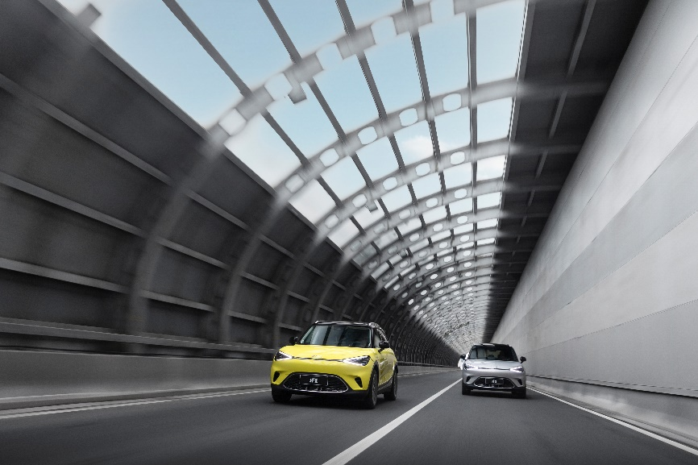
smart is committed to building an industry-leading, intelligent assisted driving platform

-End-

For the latest information, please visit
smart Global Media Centre: https://media.smart.com/
smart Automobile Website: https://www.smart.cn/

Media Inquiries
Jingyi Xiang: jingyi.xiang@smart.com

smart mini program

About smart Automobile
Since the birth of the brand in the 90s, smart has always maintained the vision of exploring the best solutions for future urban mobility. In 2019, smart Automobile Co., Ltd. was officially established. With a forward-looking "China-Europe dual-home" global development strategy, smart is committed to developing into a world-leading, new-premium, intelligent and all-electric auto brand.
smart has completed a comprehensive renewal of its brand, product and business model. The new generation all-electric product development is led by the smart R&D team, with the Mercedes-Benz global design team responsible for vehicle design, and the product portfolio now expanded into more market segments. As the renewed brand's first compact all-electric SUV, the smart #1 made its world premiere in April 2022, with initial deliveries in China followed by Europe. Every year from 2022 to 2024, smart will bring an all-new model to customers, further enriching the new generation all-electric product portfolio.

