Press Release
October 10, 2022

Following the official delivery kicked off in China
Over 500 units of the All-New smart #1 delivered in the first week

- In just a week since the start of delivery of the first batch of all-new smart #1 vehicles on September 23rd in China, more than 500 have been delivered.
- Production work on the all-new smart #1 is progressing as planned and on schedule.
- smart has completed the building of around 140 offline touchpoints and is expected to have more than 150 independent points of sale & service across the country by the end of 2022.
- Deliveries of the all-new smart #1 will begin in the European market in early 2023 and in Malaysia in the fourth quarter of 2023.
- Every year from 2022 until 2024, smart will bring an all-new model to the market, entering different segments and enriching the new generation all-electric product family lineup.
(October 10, 2022, Hangzhou) With delivery of the first batch of production vehicles officially kicked off in China on September 23rd, smart, the premium all-electric automotive technology brand has reached another milestone in the history of the company's development. As of September 30th, within just one week of delivery, more than 500 vehicles have been delivered to customers. The moment this journey begins, smart remains ever “customer-centric, data-driven”, constantly attuned to customer feedback to improve the quality and efficiency of delivery and service.
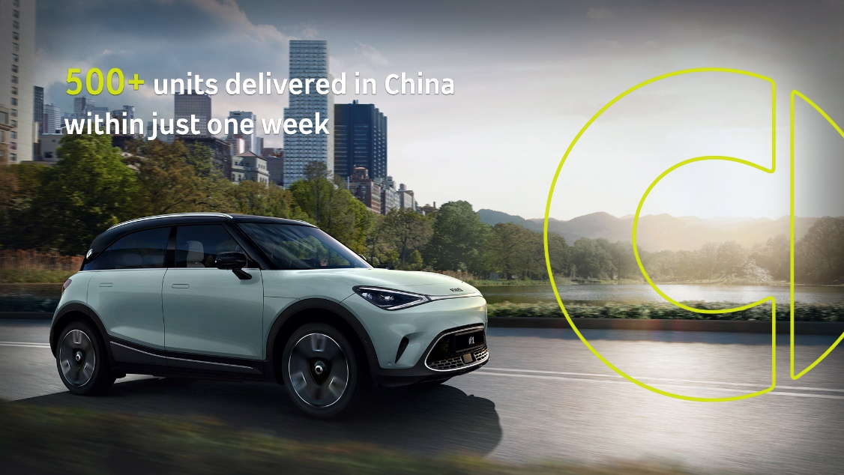
Over 500 units delivered in the first week
Following the official delivery kicked off in China
Production and delivery gather pace, with continuous improvements to service
Production work on the all-new smart #1 is progressing as planned and on schedule. With world-leading industry 4.0 automobile production technology, strict product quality standards and a rigorous supply chain management system, customers can be assured that every smart on the market will be the most reliable of companions.
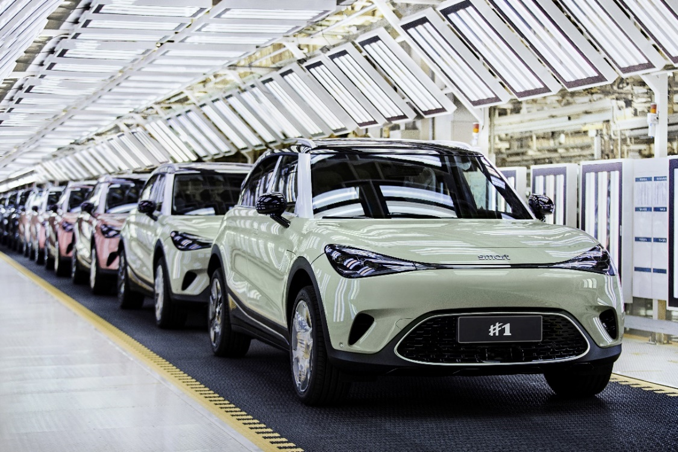
All-new smart #1 production related work is progressing steadily in an orderly manner
Construction on smart's 100th independent sales and service touchpoints in China was officially completed on August 31st, a full month earlier than expected. As of today, smart has completed the building of 140 offline touchpoints. By the end of 2022, smart brand will have more than 150 points of sale & service across the country, covering more than 40 first-tier, new first-tier and second-tier cities. As the offline network grows, smart will co-create with new retail partners to continuously improve service and customer satisfaction.
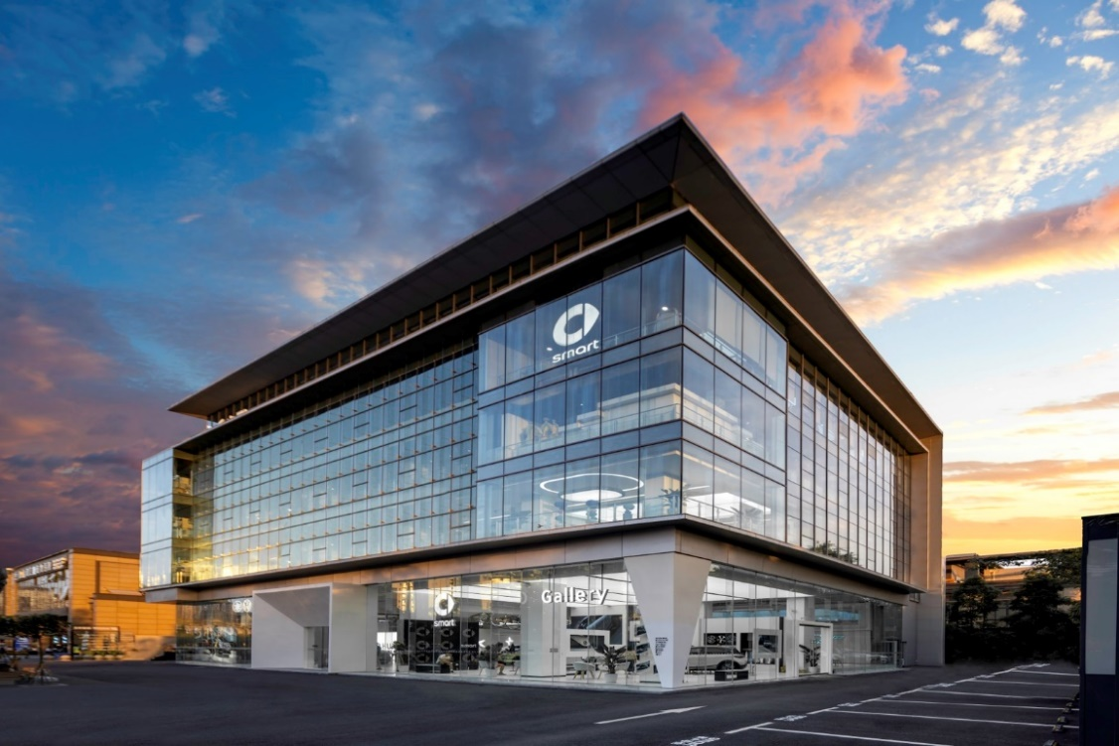
smart has completed the construction of nearly 140 offline channel outlets
Global layout advancing rapidly, the all-new smart #1 is expected to be delivered in Europe in early 2023

smart’s forward-looking "China-Europe dual-home", global development strategy means the company has a strong presence in the world’s two major electric vehicle markets. Meanwhile, the general distribution agreement signed on August 18th with PROTON covers Malaysia and Thailand, deepening global operations. Furthermore, the all-new smart #1 has been awarded China’s First EU PEFCR & ISO 14067 Carbon Footprint Certificate, as well as China’s first EU WVTA e1 certification, laying a solid foundation for greater expansion into the European new energy vehicle market.
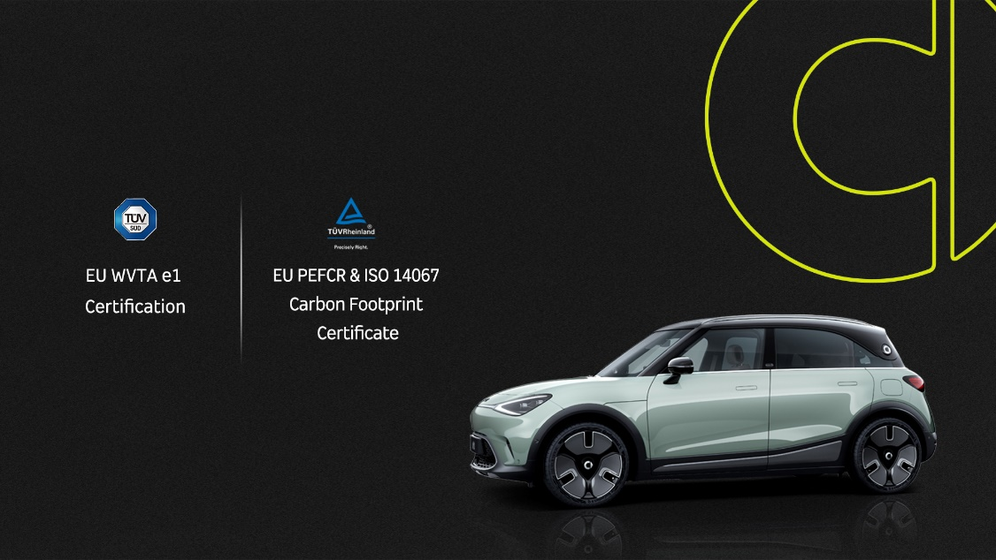
All-new smart #1 obtained EU double certification
In Europe, smart also adopts the "customer-centric, data-driven" D2C agent-based business model, working closely with long-term strategic partners and leading in the establishment of 300 points of sales and service across 14 European markets (including the UK and Switzerland). Deliveries of the all-new smart #1 will begin in the European market in early 2023 and in Malaysia in the fourth quarter of 2023.
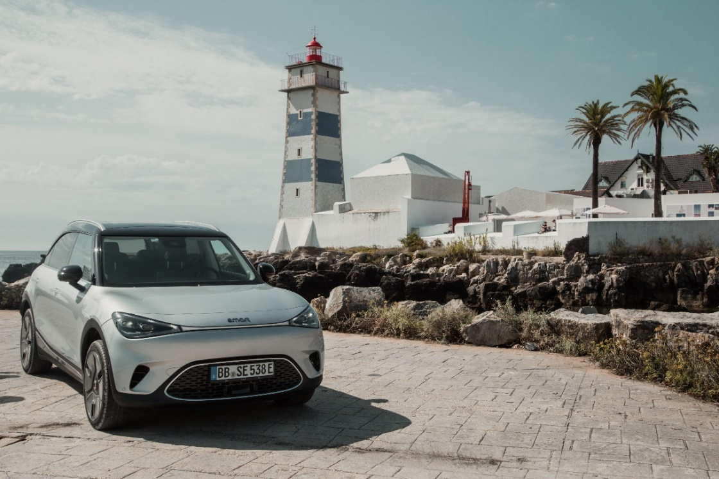
All-new smart #1 will be delivered in the European market in early 2023
(pictured in Lisbon, Portugal)
Every year from 2022 until 2024, smart will bring an all-new model to the market, entering different segments and enriching the new generation all-electric product family lineup. Maintaining the vision of "exploring the best solutions for future urban mobility", smart will continue to strive to become the world's leading premium all-electric automotive technology brand through ongoing innovation, to design a smarter future together!

-End-

smart mini program | smart official APP

For the latest information, please visit
smart Global Media Centre: https://media.smart.com/
smart Automobile Website: https://www.smart.cn/

Media Inquiries
Sebastian Liu: sebastian.liu@smart.com

About smart Automobile
Since the birth of the brand in the 90s, smart has always maintained the vision of exploring the best solutions for future urban mobility. In 2019, smart Automobile Co., Ltd. was officially established. With a forward-looking "China-Europe dual-home" global development strategy, smart is committed to developing into a world-leading, premium, all-electric automobile and technology brand.
smart has recently completed a comprehensive renewal of its brand, products, and business model. New generation all-electric product development is led by the smart R&D team, with the Mercedes-Benz global design team responsible for vehicle design, and the product portfolio now expanded into more market segments. The renewed brand’s first all-new all-electric SUV, the smart #1, which premiered worldwide in April, is now on sale in China, with official deliveries from September. To further enhance its global operations, smart has established marketing and sales centres across China and Europe.

