Press Release
November 1, 2022

Deliveries up 287% Month-On-Month
1,629 Units of the All-New smart #1 Delivered in China in October

(November 1, 2022, Hangzhou) The premium all-electric automobile and technology brand smart today officially announced delivery data for October 2022. From October 1-31, a total of 1,629 units of the all-new smart #1 were delivered in China, a month-on-month increase of 287%. smart is continuously making efficiency improvements to production and delivery. Meanwhile, by optimising the business training team, smart is further strengthening synergy with new retail partners, and is committed to delivering a better brand, product and service experience to customers.
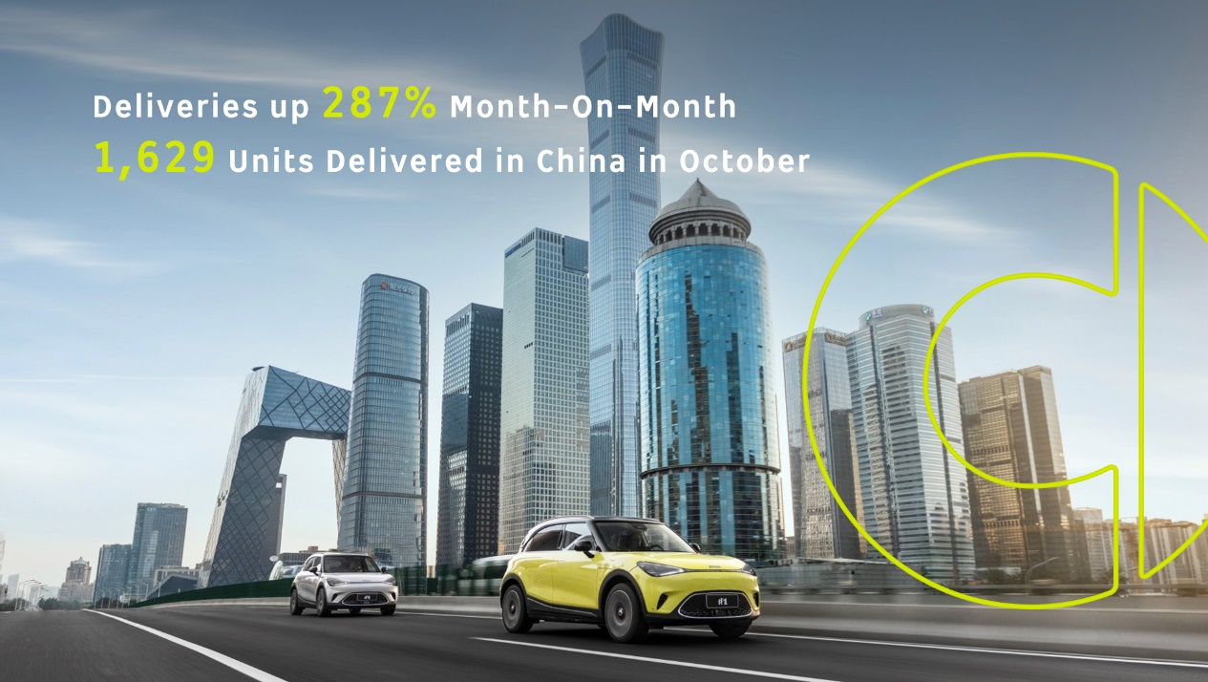
Improving Efficiency in Production and Delivery
Taking a global view, the new energy vehicle market continues to be affected by uncertain factors, such as the global pandemic and pressure on the supply chain for chips and key components. Facing the current challenges with the strong support and effective teamwork of Chinese and German shareholders, smart has taken a series of pragmatic measures to improve supply chain issues, with a view to enhancing production and delivery capabilities.
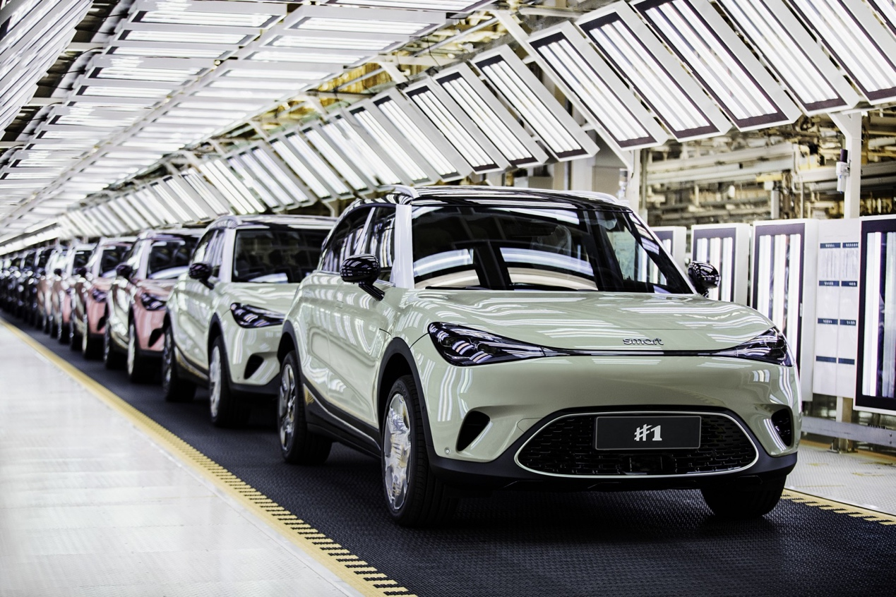
smart will continue to enhance production and delivery capabilities
On October 21, smart Automobile Co., Ltd. reached a strategic partnership with a syndicate formed by Shanghai Pudong Development Bank, China Construction Bank, Bohai Bank, Bank of Communications, Agricultural Bank of China, China Minsheng Bank, and China Guangfa Bank, receiving a more than RMB 8 billion in credit. The loan facility will not only further improve production efficiency and shorten the delivery cycle, but also help the smart brand to make breakthroughs in R&D, the business, products and services, ensuring the promise of an all-new model every year from 2022-2024 is kept.
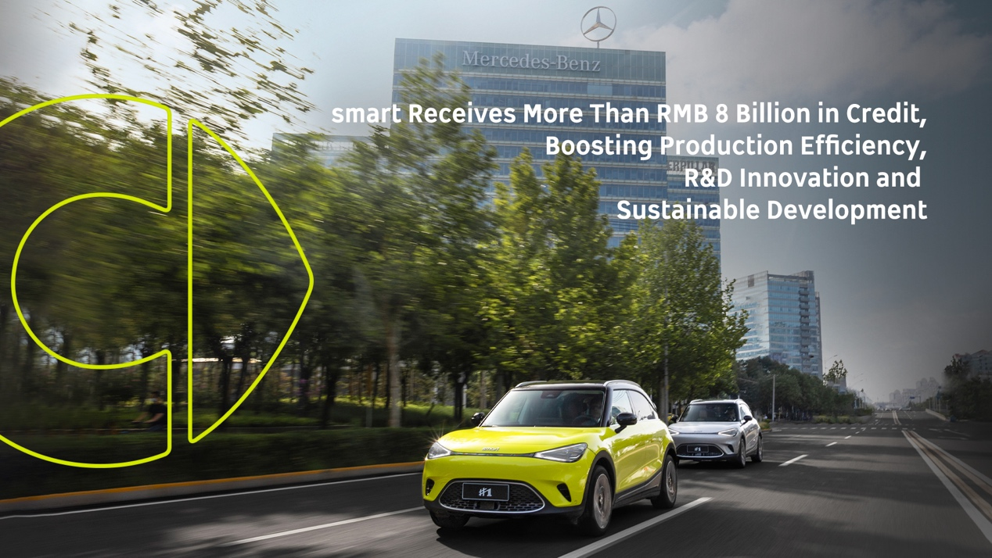

Working Together with Partners to Consolidate Efficiency and Quality in Service
In alignment with the principles of “customer-centric, data-driven”, smart adopts a D2C agent-based business model in China and Europe. Since the first batch of smart showrooms opened on June 20 this year, in just 4 months, smart has completed the establishment of nearly 140 offline touchpoints. It is estimated that by the end of 2022, the smart brand will have more than 150 independent points of sales and service, covering more than 40 first-tier, new first-tier and second-tier cities.
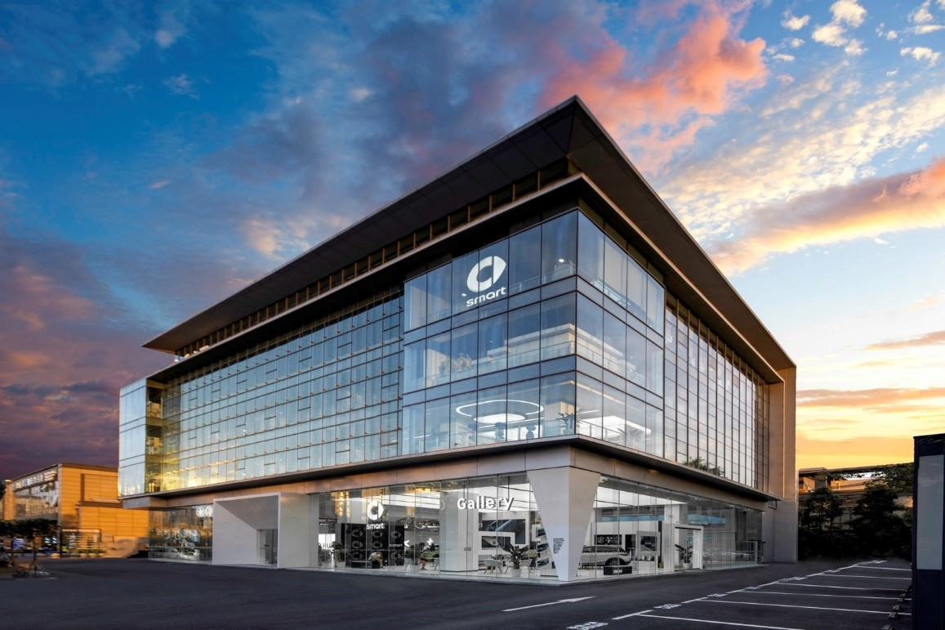
smart has completed the establishment of nearly 140 offline points of sales and service
smart’s innovative business model cannot rely solely on the expansion of offline sales and service networks. While increasing “quantity”, improving “quality” is the key to strengthening service and improving customer satisfaction. smart currently has a professional training team which will provide smart’s new retail partners with a full range of brand, product and service knowledge empowerment, as well as optimise the level of service of front-line personnel. Meanwhile, new retail partners can provide genuine customer feedback to the brand, allowing smart to better understand the market needs, achieving a win-win with partners, and putting “customer-centric” into action.
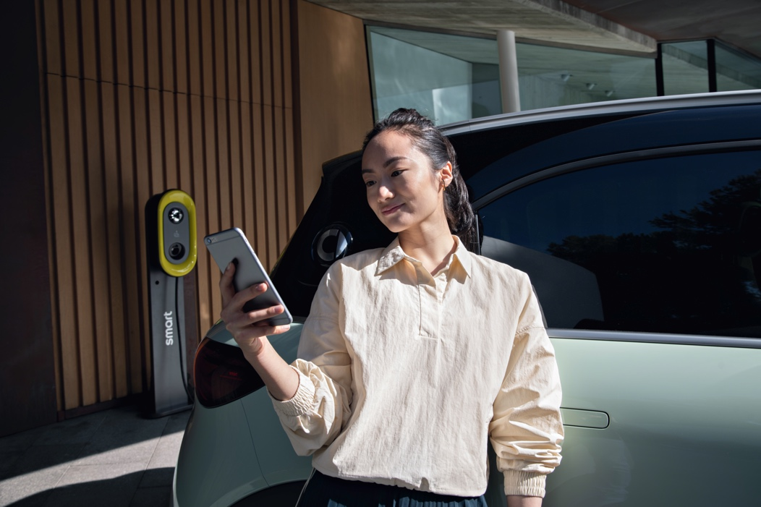
smart adopts a "customer-centric, data-driven" D2C agent-based business model into action
2022 is a year of comprehensive renewal for smart’s brand, product and business model. From April to the current half year, smart has brought the all-new smart #1 to the Chinese market, built a near-complete online and offline network, and began official delivery of the first batch of products ahead of schedule. In the future, smart will continue to work with customers and partners to design a smarter future together!
-End-

For the latest information, please visit
smart Global Media Centre: https://media.smart.com/
smart Automobile Website: https://www.smart.cn/

Media Inquiries
Sebastian Liu: sebastian.liu@smart.com

smart mini program

About smart Automobile
Since the birth of the brand in the 90s, smart has always maintained the vision of exploring the best solutions for future urban mobility. In 2019, smart Automobile Co., Ltd. was officially established. With a forward-looking “China-Europe dual-home” global development strategy, smart is committed to developing into a world-leading, premium, all-electric automobile and technology brand.
smart has recently completed a comprehensive renewal of its brand, products, and business model. New generation all-electric product development is led by the smart R&D team, with the Mercedes-Benz global design team responsible for vehicle design, and the product portfolio now expanded into more market segments. The renewed brand’s first all-new all-electric SUV, the smart #1, which premiered worldwide in April, is now on sale in China, with official deliveries from September. To further enhance its global operations, smart has established marketing and sales centres across China and Europe.

