Press Release
November 3, 2022

First Ever smart PERFORMANCE DAY Grand Opening at Xiamen International Circuit
(November 3, 2022, Xiamen) After a 20-year collaborative history, smart and BRABUS have joined hands again to continue their co-authored legend. As the first co-creative masterpiece of the all-electric era, the all-new smart #1 BRABUS delivers an exciting, high-performance, all-electric urban driving experience. Today, smart brings this latest model to Xiamen International Circuit, for drivers to enjoy the all-electric smart feel at the grand opening of the first ever "smart PERFORMANCE DAY".
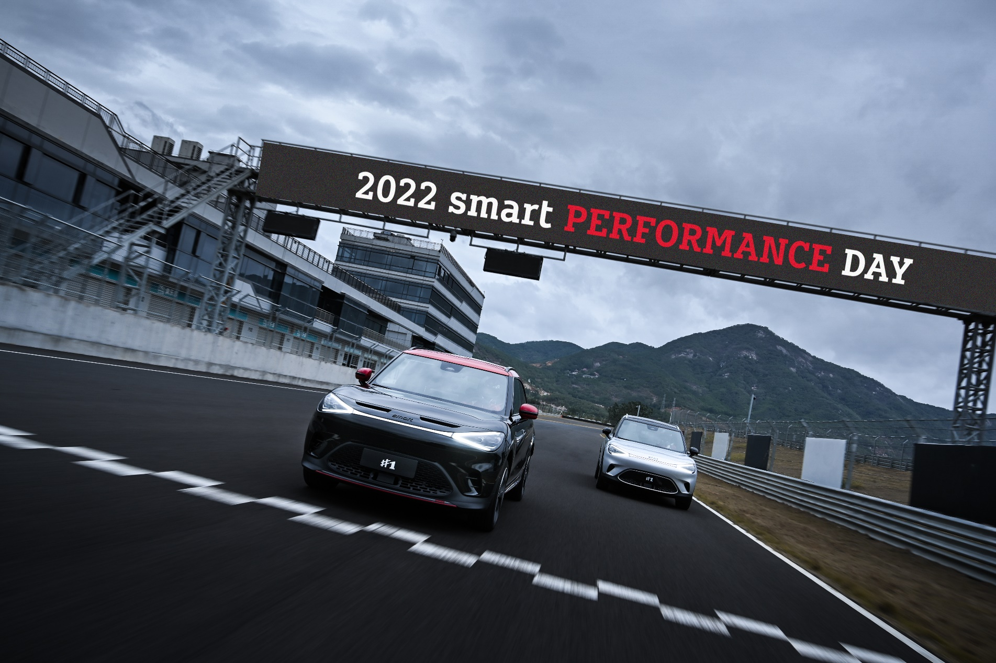
The first ever smart PERFORMANCE DAY Opening at Xiamen International Circuit

Mandy Zhang, Vice President of Global Sales, Marketing and After-Sales of smart Automobile Co., Ltd. said: "As one of the core elements rooted in our brand's DNA, 'avant-garde co-creation' is reflected not only in smart products and the lifestyles we advocate, but also integrated into our operating philosophy. Whether with the highly popular ‘smart times’, or today's smart PERFORMANCE DAY, we love to collaborate with customers to co-create and to see more friends join hands with smart, to design a smarter future together! "
Mandy Zhang, Vice President of Global Sales, Marketing and After-Sales of smart Automobile Co., Ltd.
Since its official launch at the 25th Chengdu Auto Show on August 26th this year, smart #1 BRABUS has been a hot favourite, with stock already completely sold out in China this year. Customers can now log in to the official smart APP to book a test drive appointment and get ahead of the line for sales of this model in 2023.

Conquering the track with all-electric power
The FIA certified F4-level Xiamen International Circuit measures 1.82 kilometres in length and includes sharp corners, hairpin turns and continuous S curves, with 11 exhilarating corners in total. Narrowing down to just 13.5 meters in parts, the course can undoubtedly test the complete driving performance of the vehicle. Thanks to nimble, precise steering and ample power, the smart #1 BRABUS makes it a breeze to conquer every corner.
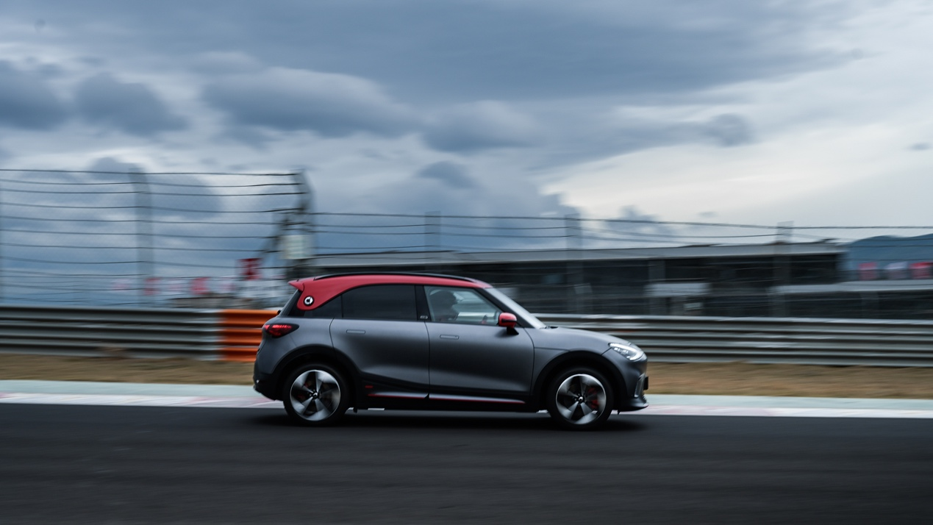
smart #1 BRABUS makes it a breeze to conquer every corner
The all-new smart #1 BRABUS is equipped with front and rear dual permanent magnet synchronous motors, which can produce a maximum 315 kW power burst, with a peak torque of 543N·m. Drivers will be amazed by the performance power with just one touch of the throttle.
In terms of the chassis, the vehicle features 8 exclusive upgrades and enhancements: the diameter of the front brake disc has increased by 7.1% to 345mm, the thickness has increased by 7.1% to 30mm, the effective radius of the friction plate has increased by 5.4% to 137mm and front suspension spring stiffness has been increased by 12%, up to 28N/mm. The improvements in the braking and suspension springs, plus the front and rear McPherson five-link independent suspension setup greatly enhances stability and handling. Especially when cornering at high speeds and full braking, the vehicle maintains a good posture, giving the driver confidence to conquer the track.
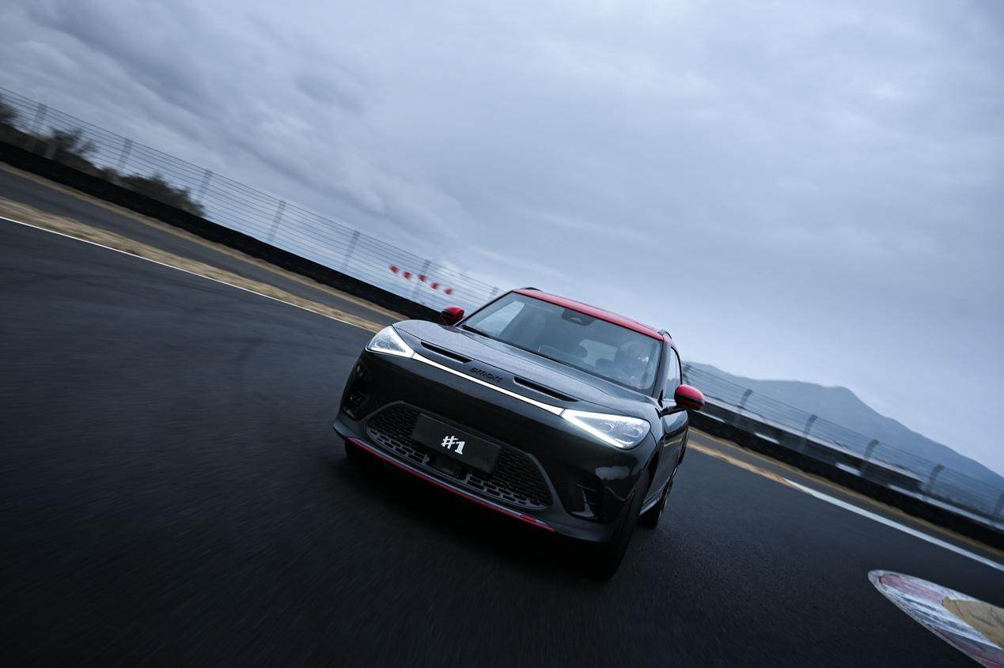
Outstanding track performance
In addition, the smart #1 BRABUS intelligent four-wheel drive system features three modes: rear-wheel drive, part-time four-wheel drive, and full-time four-wheel drive, switching between ECO/Comfort/Sport/BRABUS driving modes in just 0.4 seconds. ECO and Comfort driving modes easily meet the requirements of daily urban commuting. In Sport and BRABUS modes, especially in BRABUS mode, the front and rear motors unleash 100% of their power.
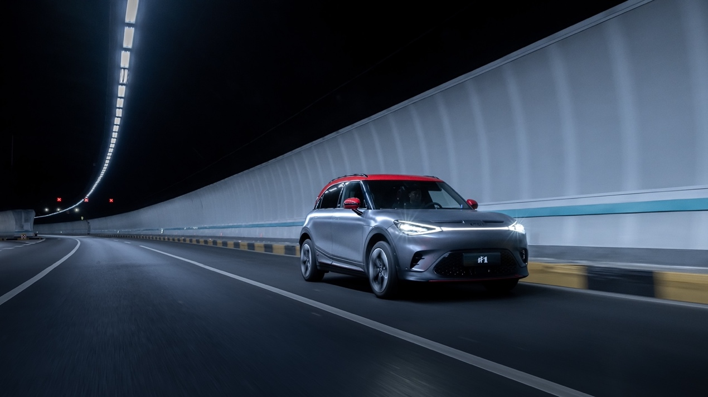
The car can switch quickly between four driving modes - Eco/Comfort/Sport/BRABUS
In addition, the all-new smart #1 BRABUS features two kinds of analog sounds, including the "smart original" sound and "classic" themes. The "smart original" sound is sampled from the previous smart BRABUS fuel version model, while the "classic" is inspired by the powerful V6 engine. At the press of a button, the power of the Beats 13-speaker audio system is released, creating the atmosphere of a high performance engine.

Stunning at a glance, obvious "track pedigree"
As the representative of smart and BRABUS entering the all-electric era, the all-new smart #1 BRABUS features many BRABUS-exclusive design elements. Coupled with the product’s design soul imbued by the Mercedes-Benz global design team, every premium detail creates a fantastic visual impact.
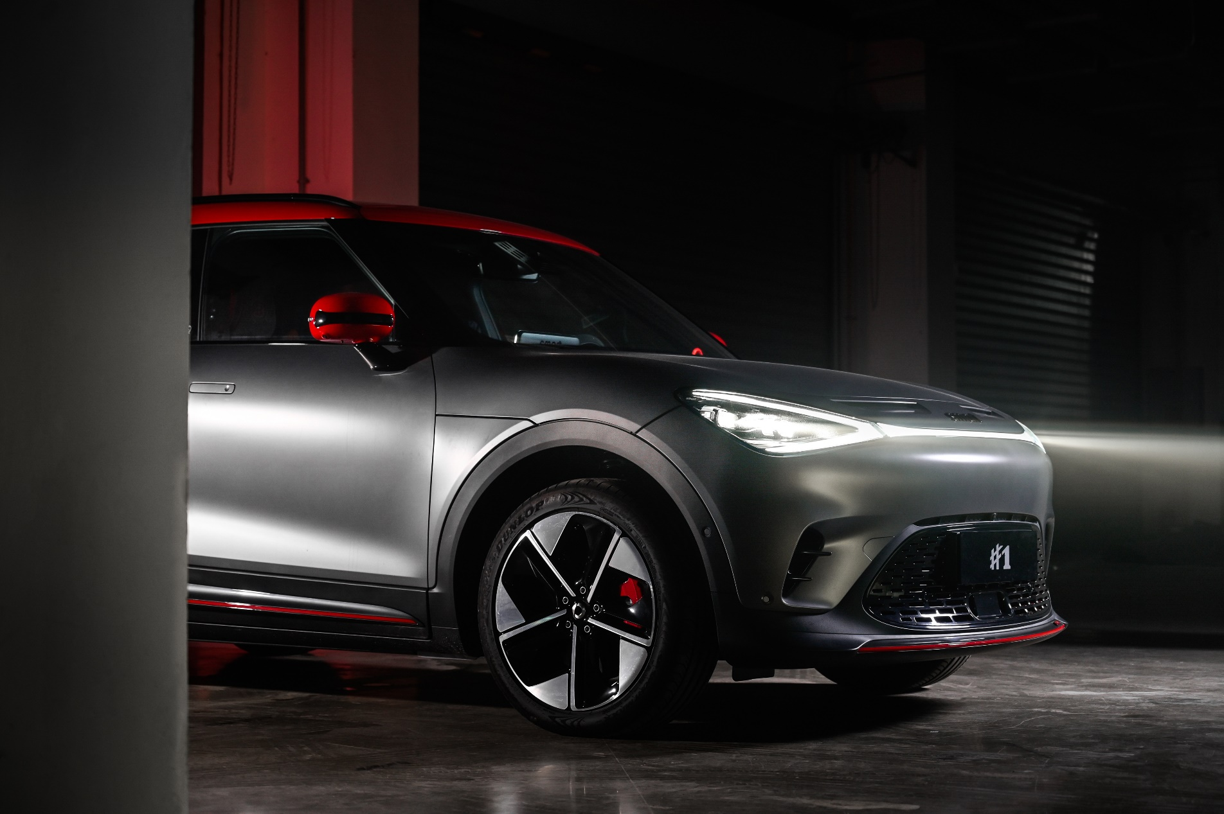
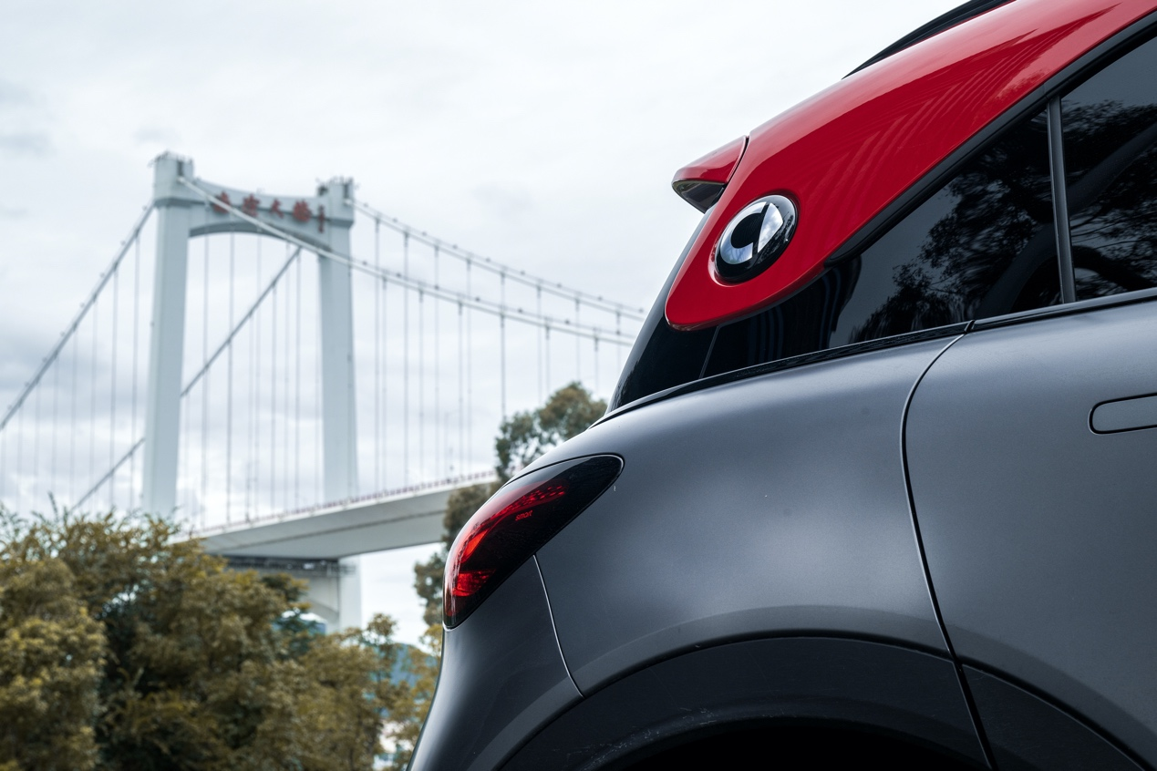
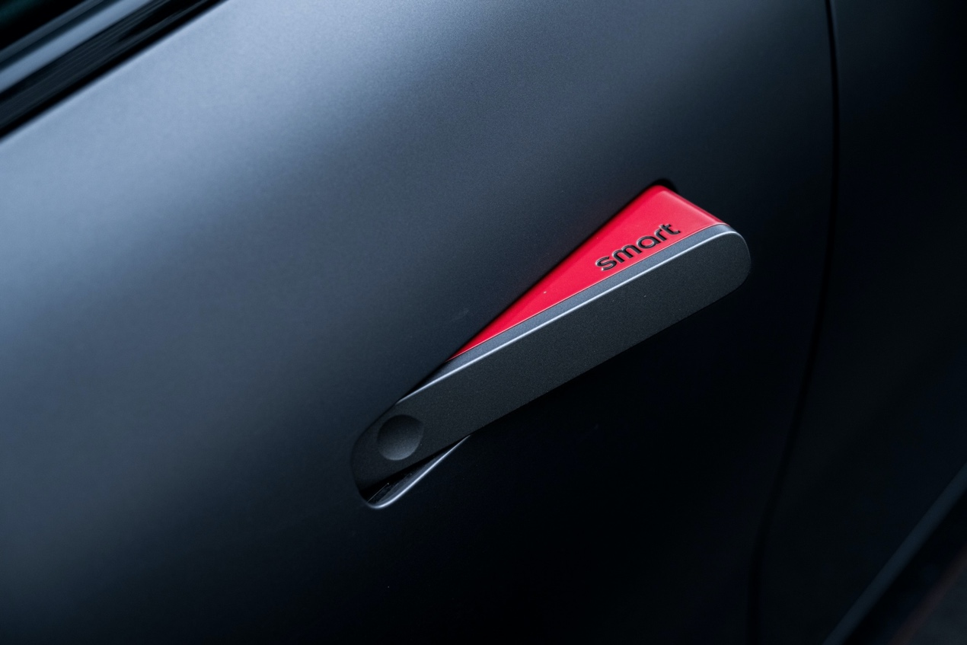
Exclusive BRABUS design elements
The all-new smart #1 Pro+ also completed several on-track challenges at the event. Equipped with a rear permanent magnet synchronous motor, the vehicle can produce of 200 kW power and a peak torque of 343 N·m, allowing for a 6.7s 0-100 km/h time. With 14 high-precision sensors to aid drivers, the model’s strengths are obviously apparent, with its distinctive performance and intelligence. With deliveries now underway, the smart #1 is zipping its way towards more new customers.
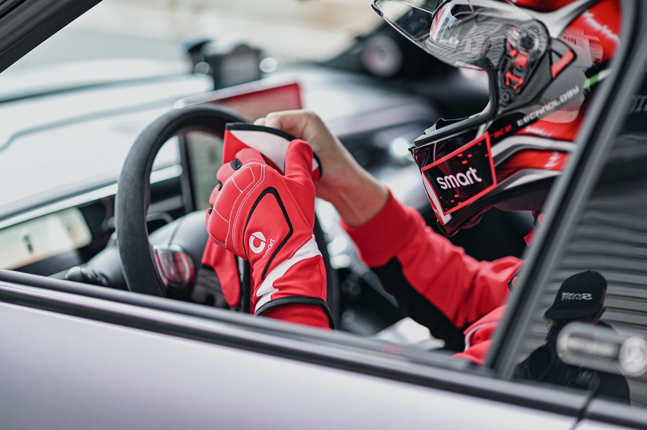
Participants felt the brilliant performance of the all-new smart #1 BRABUS
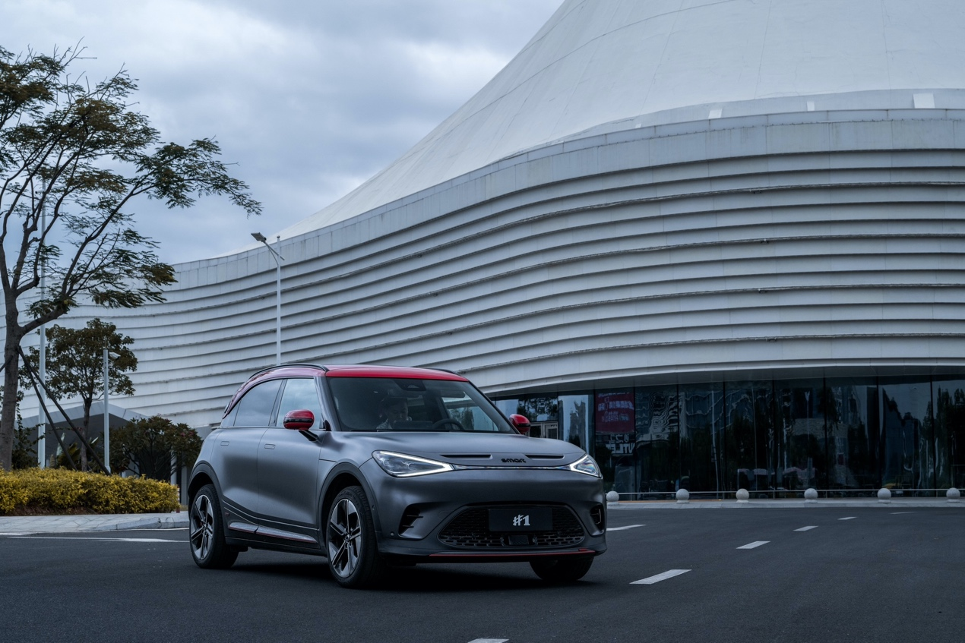
The all-new smart#1 BRABUS (Photographed in Xiamen)

One second wow, in a smart way! In future, smart PERFORMANCE DAY will continue to team up with customers to co-create more high-performance moments, to design a smarter future together!
-End-

For the latest information, please visit
smart Global Media Centre: https://media.smart.com/
smart Automobile Website: https://www.smart.cn/

Media Inquiries
Una Tu: una.tu@smart.com

smart mini program

About smart Automobile
Since the birth of the brand in the 90s, smart has always maintained the vision of exploring the best solutions for future urban mobility. In 2019, smart Automobile Co., Ltd. was officially established. With a forward-looking "China-Europe dual-home" global development strategy, smart is committed to developing into a world-leading, premium, all-electric automobile and technology brand.
smart has recently completed a comprehensive renewal of its brand, products, and business model. New generation all-electric product development is led by the smart R&D team, with the Mercedes-Benz global design team responsible for vehicle design, and the product portfolio now expanded into more market segments. The renewed brand’s first all-new all-electric SUV, the smart #1, which premiered worldwide in April, is now on sale in China, with official deliveries from September. To further enhance its global operations, smart has established marketing and sales centres across China and Europe.

