Press Release

smart officially unveils name for its new generation of all-electric vehicles
Contact:
Alicia Solanki

Telephone:
+44(0) 7870 395548

Email
alicia.solanki@ketchum.com

Datum
10 Feb 2022

All-new smart #1 successfully completed stringent pre-market tests

Leinfelden-Echterdingen, February 10, 2022. With the renewal of its brand, product and business model, smart has entered a new era of development. As a premium all-electric automotive technology brand, smart is expanding its product portfolio and has officially unveiled the nomenclature for its new generation of vehicles.
As the first production model in the family, the all-new smart #1 recently completed a series of aerodynamic and winter tests. The model’s quality, performance and reliability demonstrate the power of seamless cooperation between Mercedes-Benz global design team and smart’s engineering department, which bodes well for the highly anticipated model launch later this year.

Born to be a Trendsetter

With combination of the “#” symbol followed by a number, smart has defined a recognizable family name for its new generation of all-electric vehicles. Now often used to indicate the hottest topics in social media, the “#” symbol is evocative of trendsetting in the digital era - fitting, because ever since its first production car unveiling at IAA in 1997, smart has been striving for innovation and remained a trendsetter in the automotive industry.

According to Mr. Daniel Lescow, Vice President of Global Sales, Marketing and After-Sales of smart Automobile Co., Ltd., “As the first product set to launch following the brand’s renewal, the smart #1 perfectly combines electric-drive technology and premium quality. I am convinced that the smart #1 will enthuse future customers in both China and Europe, setting new trends of urban mobility and co-creating powerful brand experiences wherever it will make an appearance.”

Designed by Mercedes-Benz: A Perfect Blend of Aesthetics & Aerodynamics

The China Automotive Engineering Research Institute in Chongqing features the country’s most advanced automobile aerodynamics testing center and one of the world’s forefront. Here, the smart #1 measured a drag coefficient performance of just 0.29, a top-ranked achievement, especially when compared side by side with SUV competitors in the same segment.

This is especially important, as the drag coefficient is the core factor influencing a vehicle’s energy consumption, range, wind noise and stability at high speed. Thanks to the “Sensual Producty” design philosophy applied by Mercedes-Benz global design team, the smart #1 features a pure and elegant streamlined exterior, a perfect balance of aesthetics and aerodynamics. The concealed door handles, the highly effective aerodynamics package, as well as the AGS (Active Grille Shutter) which is equipped as standard, all contribute to elevate aerodynamic performance. Wind resistance and noise have been significantly optimized, contributing to greater energy efficiency, comfort and driving range.

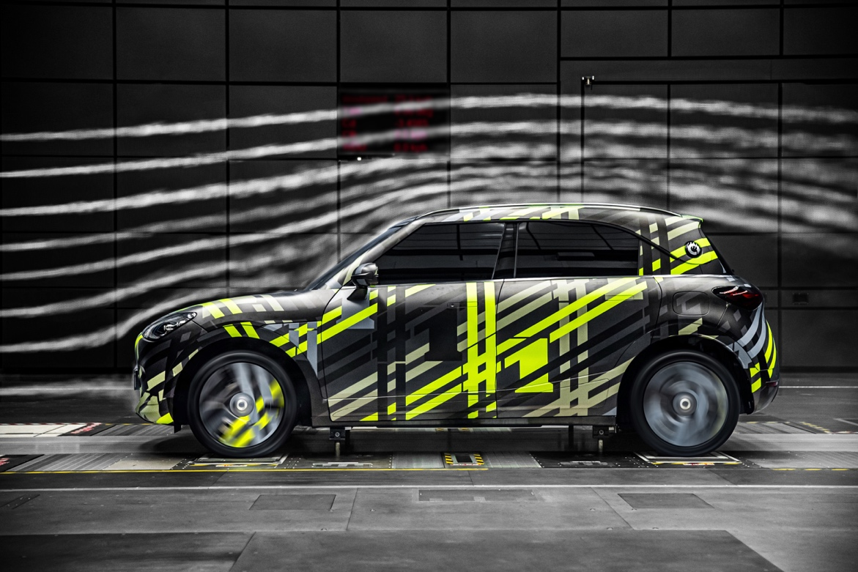
smart aerodynamic testing

No fear of ice and snow: Uncompromising Urban Companion

In the far north of China, at one of the world’s coldest testing grounds and in temperatures around -40 ℃, the smart #1 showed excellent resistance to extreme cold. The advanced battery temperature control system maintains the optimum working condition for the battery. In addition, customers can pre-set their driving schedule via the smart APP or vehicle control panel of the smart #1, in order to automatically pre-heat the battery and ensuring optimized charging and output efficiency. Meanwhile, the vehicle’s concealed door handles are equipped with ice breaking functions, working normally even when the car is covered with a thin layer of ice.

The smart #1 also underwent complex snow and ice road testing at the site, in conditions similar to daily winter urban driving. With a robust ESP system supported by Bosch and the all-electric powertrain, the vehicle combines outstanding driving comfort, handling stability, acceleration and braking performance, thus providing driving safety and pleasure. Even in the coldest weather, the all-new smart #1 will remain an uncompromising urban companion for its users.

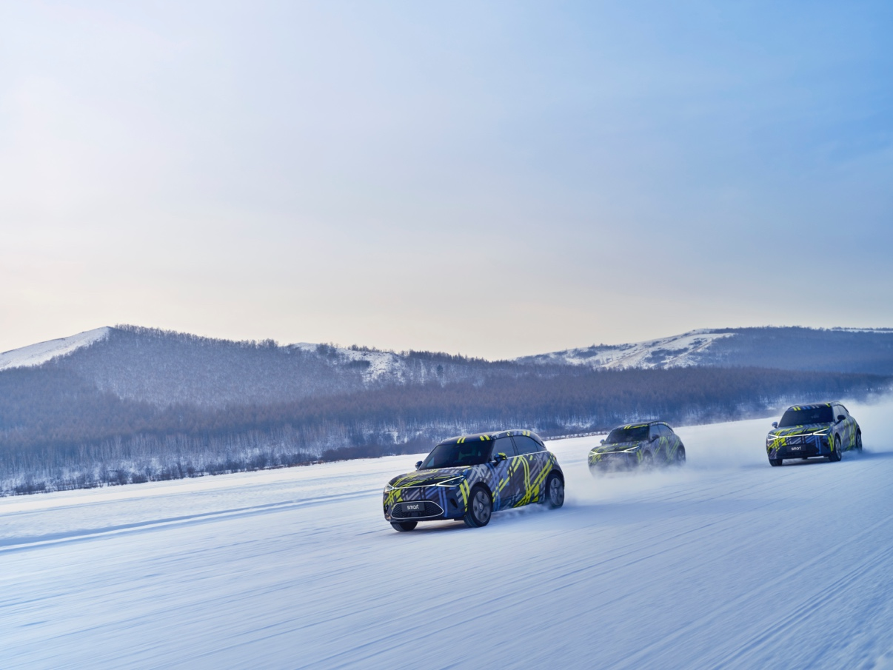
smart winter testing (1)

Mr. Yang Jun, Vice President of Research and Development of smart Automobile Co., Ltd. said, “Thanks to the seamless cooperation between smart and the Mercedes-Benz design team, the smart #1 is a masterpiece of engineering. The pre-market test results also prove the outstanding quality, performance and reliability of the smart #1. With the car due to launch later this year, these developments make us confident that it will be well received by its future customers.“

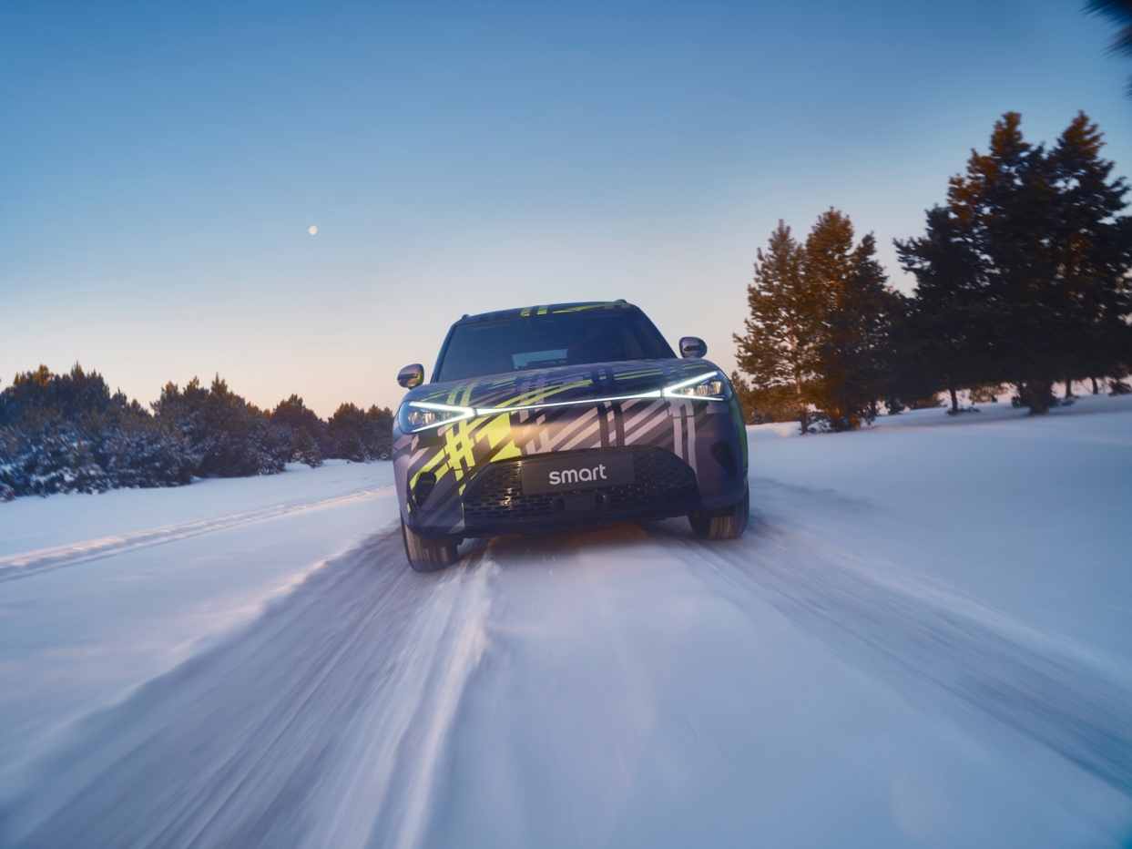
smart winter testing (2)

In the digital age, the renewed smart brand remains committed to its vision of exploring the best solutions for future urban mobility and co-creating with avant-garde spirited. With Mercedes-Benz design and smart engineering, the all-new smart #1 perfectly encapsulates the smart’s purpose - to design a smarter future, together.

For further information about smart, please visit https://media.smart.com/eu.

Contact:

Alicia Solanki
alicia.solanki@ketchum.com
+44 (0) 7870 395548

smart Europe Press Office at Ketchum
Andrea Seemüller, Vincent Zimmermann
smart@ketchum.de
+49 (0) 211 9541 0

Julia Brehm
Head of communications at smart Europe
julia.brehm@smart.com

About smart Europe GmbH
smart Europe GmbH was founded in June 2020 as a wholly owned subsidiary of smart Automobile Co., Ltd. Based in Leinfelden-Echterdingen, near Stuttgart, smart Europe’s international team is responsible for all sales, marketing and after-sales activities for the next generation of smart vehicles, products and services of the smart brand in the European market. With Dirk Adelmann as CEO and Martin Günther as CFO, the company is developing its full potential in Europe with a highly efficient and customer-oriented business model.
smart Automobile Co., Ltd. was established as a global joint venture between Mercedes-Benz AG and Geely Automobile Co., Ltd. The aim is to position smart as a leading provider of intelligent electric vehicles in the premium segment. The first SUV model will be presented in 2022.

