Press Release

Tomorrow is yours with the smart #1
Contact
Julia Brehm

Region
smart Europe

E-mail
julia.brehm@smart.com

Date
07.04.2022

smart celebrates the start of tomorrow's mobility today with the world premiere of the all-new compact SUV – smart #1
Berlin, 07, April 2022. Mobility nowadays: it brings people together, connects ideas and cultures, and sparks a variety of shared experiences. At this moment in time, technology has finally become an enabler for people, adapting to their lifestyles rather than vice versa. As a result, the development of the automobile away from simple means of transportation has reached new heights. It becomes a close companion. This is the core of smart #1.

Tong Xiangbei, Global CEO of smart Automobile Co., Ltd. says: "The world premiere of the smart #1 in Berlin marks another milestone on the incredible road of development we began with the brand's renewal. As the first of the new generation all-electric product family, the all-new smart #1 is the perfect embodiment of this renewal. Now, smart has entered a new phase of full speed development, further spurred on by our Europe and China "dual-home" business strategy. Our team, working between Europe and China, are making fantastic progress, and we are extremely confident that the global market will embrace the unique, premium all-electric urban mobility experience offering from smart."

Design that redefines space and breaks boundaries
The form of the smart #1 is shaped by new design, new technology and a new approach to create an urban companion. Just like the smart brand itself, the values of the design are an invitation to connect with the car on a purely personal level. The exterior is forward-thinking and progressive with elements such as concealed electric door handles, frameless doors, and the floating halo roof that users would not expect on a car in this category. At every angle there is always a new detail to explore. The space to footprint ratio is pushed to the maximum: The all-new smart #1 with its 4270 mm length, wheelbase of 2750mm and the max. 19” inch rims are creating an impressive interior space with an enhanced 360° view.

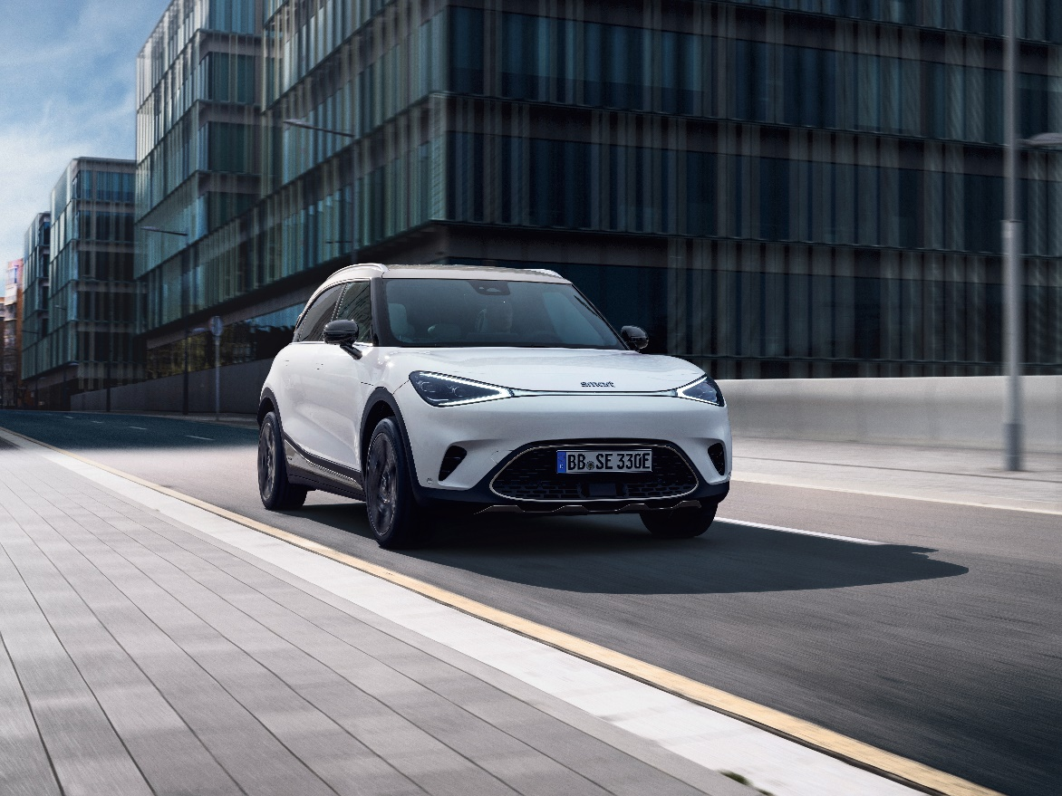

Gorden Wagener, Chief Design Officer Mercedes-Benz AG: “The new smart #1 stands for the re-start of the smart brand and showcases our new design DNA of Sensual Producty”, says Gorden Wagener, Chief Design Officer Mercedes-Benz Group AG.
“It is grown up, cool and embodies beauty with smart solutions. Therefore, it is new, fresh, and enchanting. Our new smart #1 has the potential to make smart a leading design brand.”
Connectivity and user-centricity as standard for today’s mobility
smart #1 is putting the customer at the center. With a dedicated app environment and customizable infotainment user interface, the car embraces purposeful and human-centric technology to connect people, places, and experiences both virtually and in real life. The all-new smart will feature an avatar as intelligent companion with AI based voice control within its user interface. This seamlessly ties into the interconnected ecosystem of the car, the smart app, and data clouds – all linked with personal smart ID and protected by highest cyber security encryption standards.

To meet the needs of users in terms of ever-changing mobility, the all-new smart #1 and all connected products and services form one coherent, intuitive, and adapting ecosystem. A centralized, high-performance computing architecture ensures dynamic over the air updates so that more than 75 % of all ECUs in the car can be continuously iterated and updated remotely (OTA). In combination with full integration of the customizable ambient lighting and operating menus, driving and interacting with the car becomes a natural and immersive experience.
smart sees the advanced technologies in the car as enablers for an authentic and worry-free electric mobility experience. The smart #1 launch specification provides a 200kW peak performance and will be capable of AC charging from 10-80 % with 22kW in 3 hours. With DC super-fast charging this can be accomplished in under 30 minutes. The compact SUV allows users to connect the smart #1 with friends via app and includes a digital key with a peer-2-peer-system. As a matter of course, the smart #1 is also designed to ensure passenger safety as best by a range of driver assistant systems.

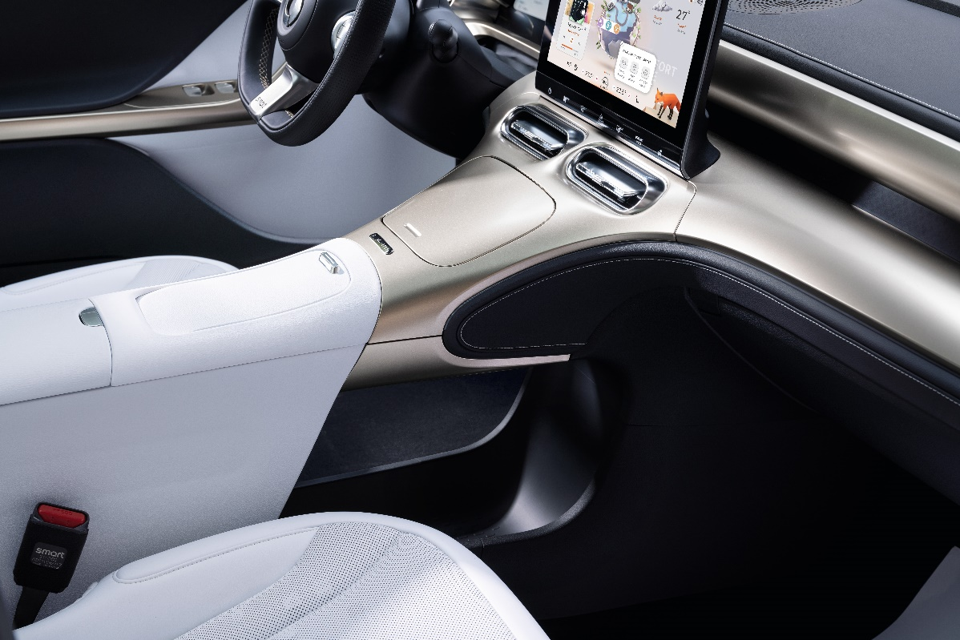

The smart business model of the future
Since smart is committed to uncompromising quality of experience and interactions, the company creates a progressive and intuitive digital ecosystem for its customers that puts experience first and redefines the concept of commerce and daily mobility. Together with a network of experienced partners, smart will provide a real and customer-oriented omni-channel experience along the entire customer journey: The user decides when and where to gather information, create experiences, make the purchase, or just stay in dialog with smart – while ensuring a seamless switch from online to offline and back. For that reason, a full embedded physical retail will remain a key success factor of the business model.

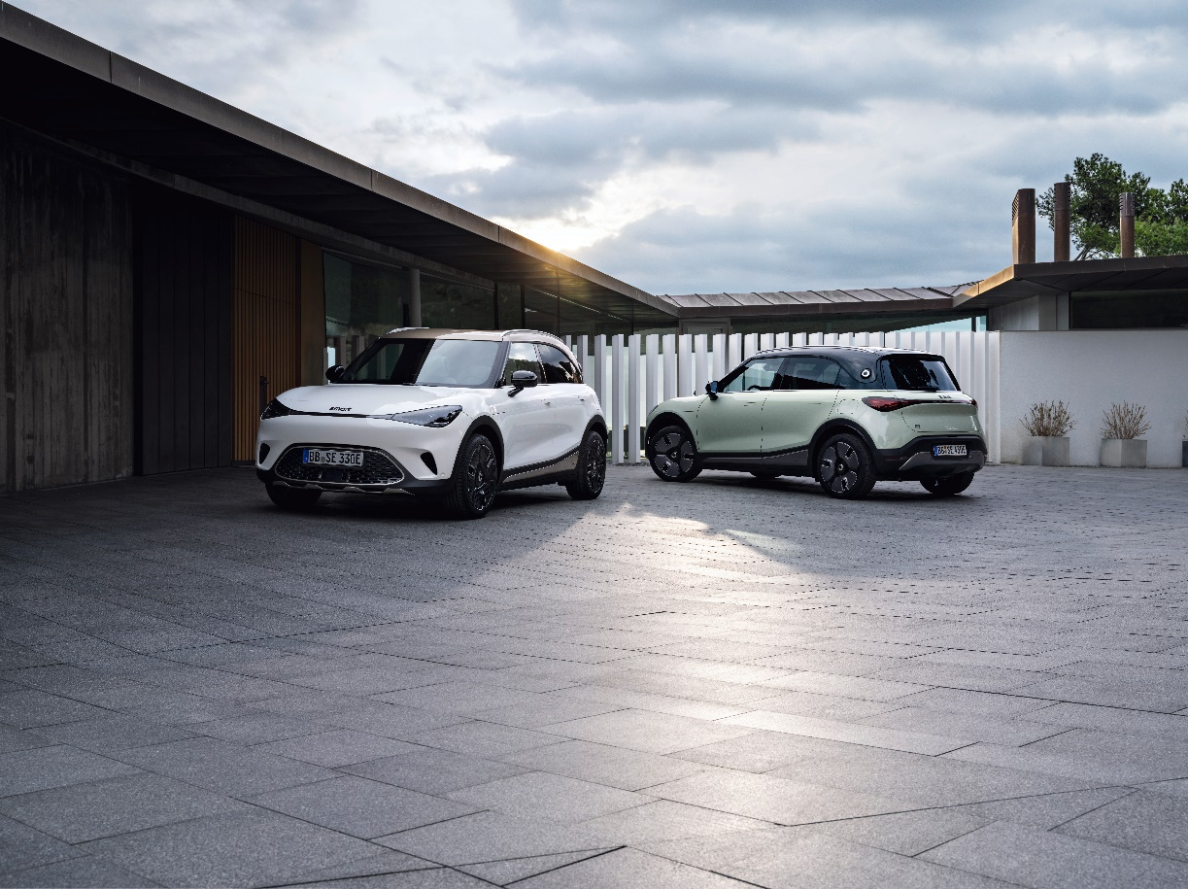

Dirk Adelmann, CEO smart Europe GmbH: “We are very proud to finally present the production version of our smart #1. It is not only a symbol for our new smart approach, but it is also the nucleus of all things to come. With the re-branding we will put an even greater focus on a seamless mobility experience.

In Europe, smart works closely together with long-trusted strategic partners to set up the most suitable and right-sized network. With their new design, the smart showrooms will reflect the new design DNA and the premium appearance of the smart brand, welcoming customers to experience the all-new smart vehicles.

Additional material:
- Overview of product specifications
- Overview of features and related images
- Image materials: LINK
- Video materials part 1: Link to “smart #1 press kit videos_part 1”
- Video materials part 2: Link to “smart #1 press kit videos_part 2”
(password is shared via mail)

The vehicle is in the EU homologation procedure and the homologation is expected to be completed in the second half of 2022. smart will publish the official values as soon as the homologation process is finalized. smart will publish the values through its usual channels. Further information on the official fuel consumption and the official specific CO2 emissions of new passenger cars can be found in the 'Guide to Fuel Consumption, CO2 Emissions and Electricity Consumption of New Passenger Cars', which is available free of charge at all sales outlets, from Deutsche Automobil Treuhand GmbH (DAT), Hellmuth-Hirth-Str. 1, 73760 Ostfildern Scharnhausen, and at https://www.dat.de/co2/ .

Contact:

smart Europe Press Office at Ketchum
Andrea Seemüller, Vincent Zimmermann
smart@ketchum.de
+49 (0) 211 9541 0

Julia Brehm
Head of communications at smart Europe
julia.brehm@smart.com

About smart Europe
smart Europe GmbH was founded in June 2020 as a wholly owned subsidiary of smart Automobile Co., Ltd. Based in Leinfelden-Echterdingen, near Stuttgart, smart Europe’s international team is responsible for all sales, marketing and after-sales activities for the next generation of smart vehicles, products and services of the smart brand in the European market. With Dirk Adelmann as CEO and Martin Günther as CFO, the company is developing its full potential in Europe with a highly efficient and customer-oriented business model. smart Automobile Co., Ltd. was established as a global joint venture between Mercedes-Benz AG and Geely Automobile Co., Ltd. The aim is to position smart as a leading provider of intelligent electric vehicles in the premium segment. The all-new compact SUV has been presented in April 2022.

